-- Create the database

CREATE DATABASE IF NOT EXISTS fetch_data;

USE fetch_data;

-- Create the Users table

CREATE TABLE IF NOT EXISTS Users (

ID VARCHAR(255) PRIMARY KEY,

CREATED_DATE datetime,

BIRTH_DATE datetime,

STATE VARCHAR(255),

LANGUAGE VARCHAR(255),

GENDER VARCHAR(255)

);

-- Create the Products table

CREATE TABLE IF NOT EXISTS Products (

CATEGORY_1 VARCHAR(255),

CATEGORY_2 VARCHAR(255),

CATEGORY_3 VARCHAR(255),

MANUFACTURER VARCHAR(255),

BRAND VARCHAR(255),

BARCODE BIGINT

);

-- Create the Transactions table

CREATE TABLE IF NOT EXISTS Transactions (

RECEIPT_ID VARCHAR(255),

PURCHASE_DATE datetime,

SCAN_DATE datetime,

STORE_NAME VARCHAR(255),

USER_ID VARCHAR(255),

BARCODE BIGINT,

FINAL_QUANTITY DECIMAL(10, 2),

FINAL_SALE DECIMAL(10, 2)

);

-- Top 5 Brands by Receipts Scanned Among Users 21 and Over

WITH Eligible_Users AS (

SELECT ID

FROM users

WHERE TIMESTAMPDIFF(YEAR, BIRTH_DATE, CURDATE()) >= 21

),

Receipts_Count AS (

SELECT

p.BRAND,

COUNT(DISTINCT t.RECEIPT_ID) AS Receipt_Count

FROM transactions t

JOIN products p ON t.BARCODE = p.BARCODE

WHERE t.USER_ID IN (SELECT ID FROM Eligible_Users)

GROUP BY p.BRAND

)

SELECT BRAND, Receipt_Count

FROM Receipts_Count

ORDER BY Receipt_Count DESC

LIMIT 5;

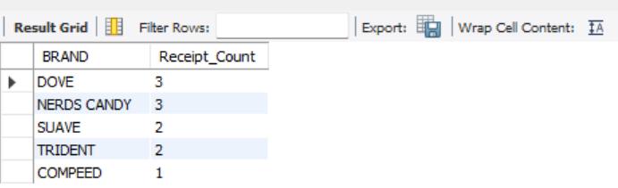

-- Top 5 Brands by Sales Among Users That Have Had Their Account for At Least Six Months

WITH Eligible_Users AS (

SELECT ID

FROM users

WHERE CREATED_DATE <= DATE_SUB(CURDATE(), INTERVAL 6 MONTH)

),

Brand_Sales AS (

SELECT

p.BRAND,

SUM(t.FINAL_SALE) AS Total_Sales

FROM transactions t

JOIN products p ON t.BARCODE = p.BARCODE

WHERE t.USER_ID IN (SELECT ID FROM Eligible_Users)

GROUP BY p.BRAND

)

SELECT BRAND, Total_Sales

FROM Brand_Sales

ORDER BY Total_Sales DESC

LIMIT 5;

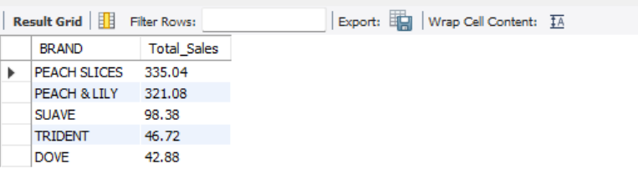

-- Who are Fetch’s Power Users?

SELECT

u.ID AS User_ID,

COUNT(DISTINCT t.RECEIPT_ID) AS Total_Receipts,

SUM(t.FINAL_SALE) AS Total_Sales

FROM transactions t

JOIN users u ON t.USER_ID = u.ID

GROUP BY u.ID

ORDER BY Total_Sales DESC, Total_Receipts DESC;

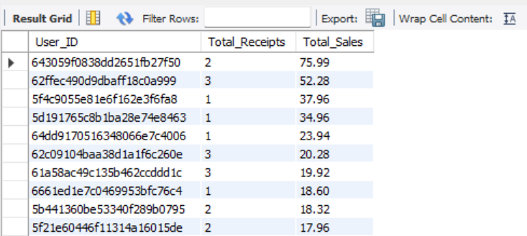

-- Which is the Leading Brand in the Dips & Salsa Category?

SELECT

p.BRAND,

SUM(t.FINAL_SALE) AS Total_Sales

FROM transactions t

JOIN products p ON t.BARCODE = p.BARCODE

WHERE p.CATEGORY_2 = 'Dips & Salsa'

GROUP BY p.BRAND

ORDER BY Total_Sales DESC

LIMIT 1;

